**Experiment 1: Create a Static Home Page by using HTML Tags**

**Aim:** The aim is to create a static home page (Resume) using HTML

**Tags Used:**

<div>

<h3>

<ul>

<li>

<table>

<td>

<tr>

<span>

**Implementation:**

**Output**

**https://kuldeep1628.github.io/resume/**

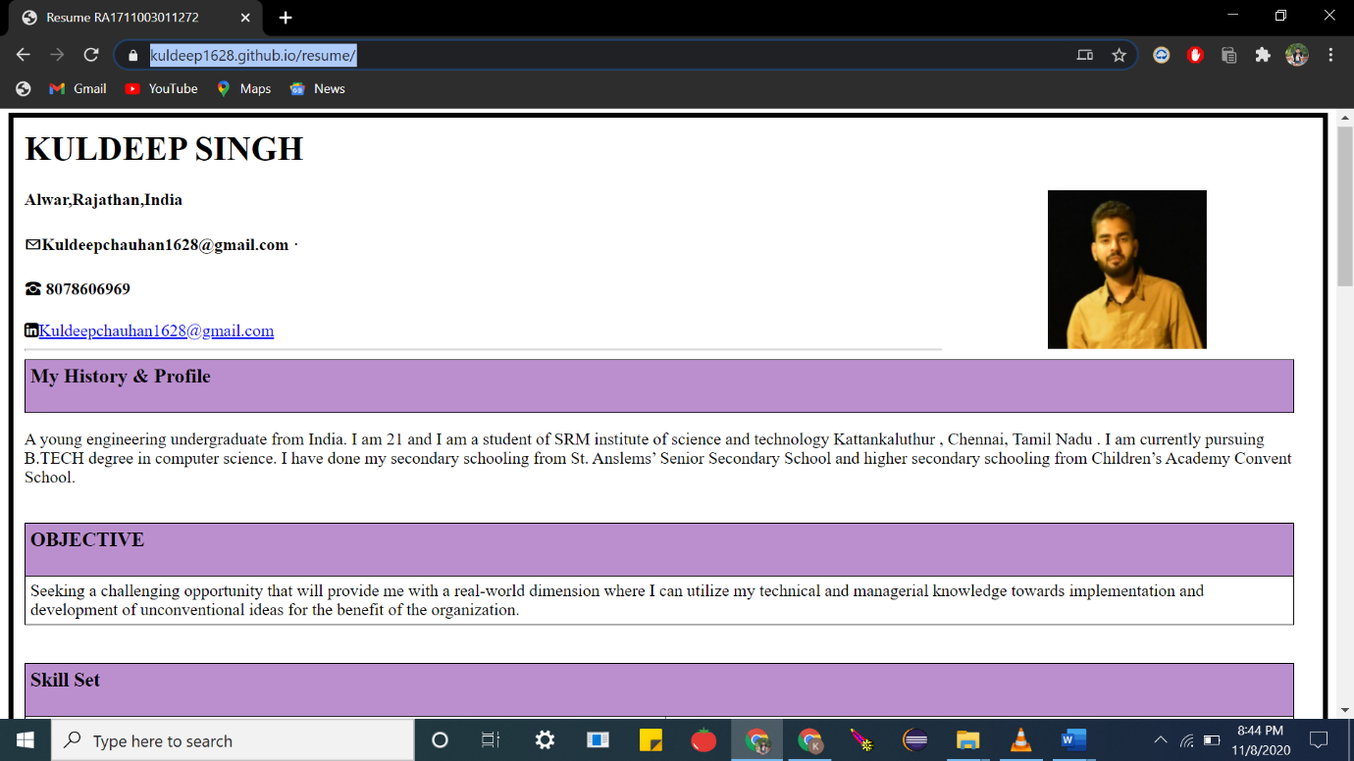

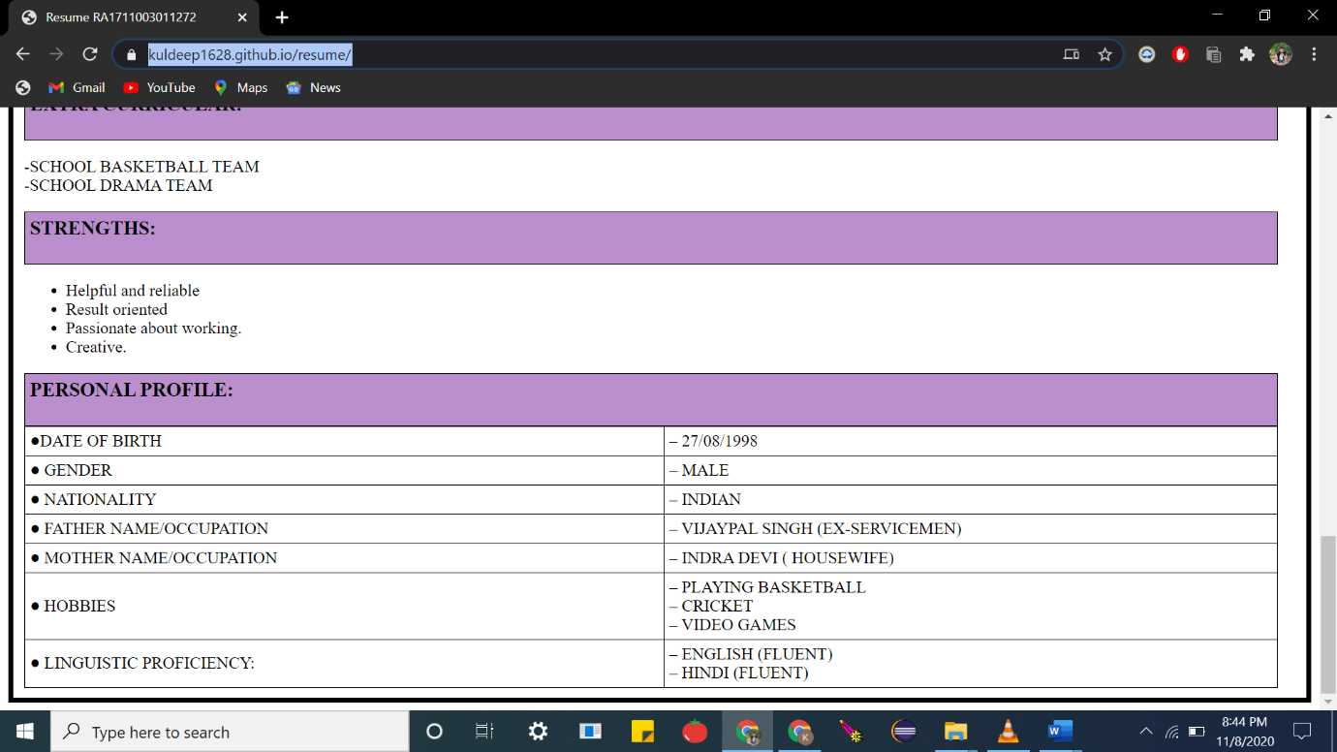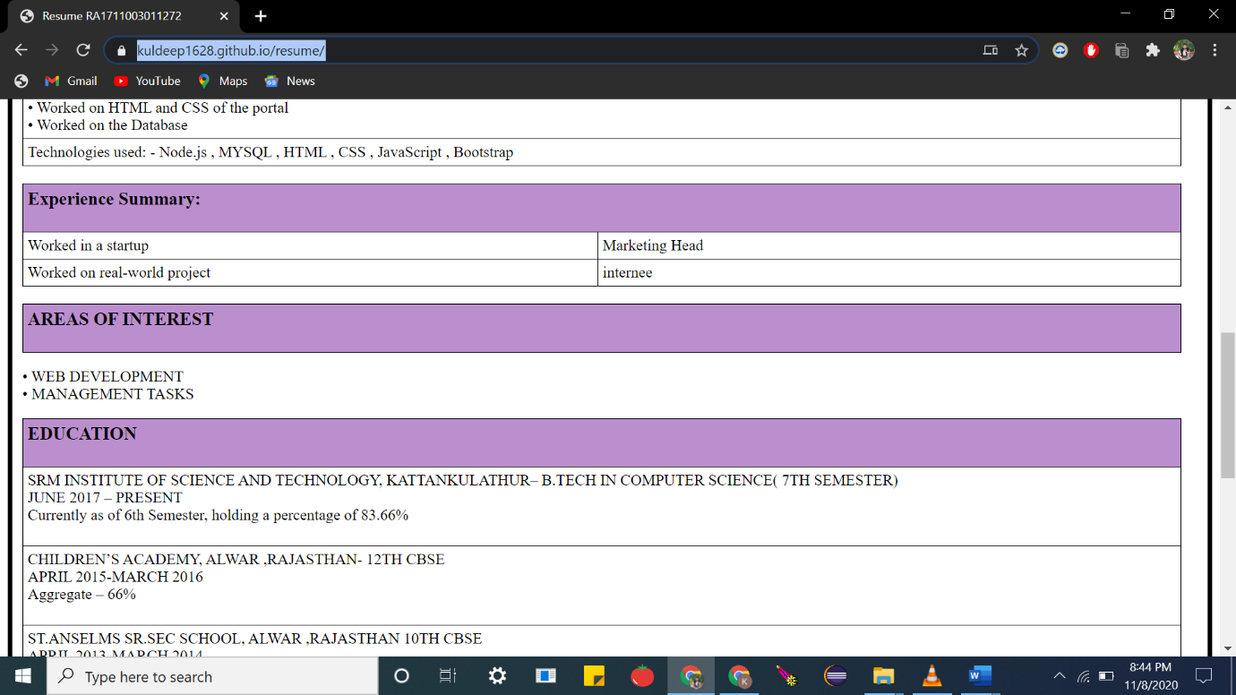

**Code**

Index.html

|  |
| --- |
| <HTML> |
|  | <head> |
|  | <TITLE>Resume RA1711003011272</TITLE> |
|  | <link rel="stylesheet" type="text/css" href="styles.css"> |
|  | <link rel="stylesheet" href="https://cdnjs.cloudflare.com/ajax/libs/font-awesome/4.7.0/css/font-awesome.min.css"> |
|  |  |
|  | </head> |
|  | <body > |
|  | <div id="heading"> |
|  | <h1>KULDEEP SINGH</h1> |
|  |  |
|  | <img src="hhf.jpg" width="150" height="150" hspace="100" align="right"> |
|  | <h4>Alwar,Rajathan,India</h4> |
|  | <span><h4>&#9993;Kuldeepchauhan1628@gmail.com ·</h4> </span> |
|  | <span><h4>&#9742; 8078606969</h4></span> |
|  |  |
|  | <i class="fa fa-linkedin-square"><a href="https://www.linkedin.com/in/kuldeep-chauhan1628/">Kuldeepchauhan1628@gmail.com</a></i> |
|  |  |
|  | </div> |
|  | <hr> |
|  | <table> |
|  | <th><h3>My History & Profile<h3></th> |
|  | </table> |
|  | <p>A young engineering |
|  | undergraduate from India. I am 21 and I am a student of SRM institute of science |
|  | and technology Kattankaluthur , Chennai, Tamil Nadu . I am currently pursuing |
|  | B.TECH degree in computer science. I have done my secondary schooling from St. Anslems’ Senior |
|  | Secondary School and higher secondary schooling from Children’s Academy |
|  | Convent School. <br><br></p> |
|  | <table> |
|  | <tr> |
|  | <th><h3>OBJECTIVE</h3></th> |
|  | </tr> |
|  | <tr> |
|  | <td> |
|  | Seeking a challenging opportunity that will provide me with a real-world dimension where I can utilize my technical and managerial knowledge towards implementation and development of unconventional ideas for the benefit of the organization. |
|  | </td> |
|  | </tr> |
|  | </table> |
|  | <br> |
|  | <br> |
|  | <table> |
|  | <tr> |
|  | <th colspan="2"><h3>Skill Set</h3></th> |
|  | </tr> |
|  | <tr> |
|  | <td>Programming languages</td> |
|  | <td>C C++ , Java , Python (basics)</td> |
|  | </tr> |
|  | <tr> |
|  | <td>Web languages</td> |
|  | <td>HTML , CSS , JavaScript (basics)</td> |
|  | </tr> |
|  | <tr> |
|  | <td>Tools Eclipse</td> |
|  | <td> Sublime Text , Visual Studio code</td> |
|  | </tr> |
|  | </table> |
|  | <br> |
|  | <table> |
|  | <tr><th><h3> |
|  | Projects : |
|  | </h3> |
|  | </th></tr> |
|  | <tr><td> |
|  | Project 1:- ( Portal) – GST Portal |
|  | </td></tr> |
|  | <tr> |
|  | <td> |
|  | Duration: - June 2019 – July 2019 <br> |
|  | Description: - The project is based upon calculating the new implemented Goods and Services tax (GST) by the Indian government. The basic is to create a database of the sales and purchases by a company or a shop and using the same data for calculating taxes b/w the dates the user wants to calculate the tax. The user just needs to enter the dates from to the date he wants to calculate taxes. |
|  | </td> |
|  | </tr> |
|  | <tr> |
|  | <td> |
|  | Key responsibilities:-<br> |
|  | • Worked on HTML and CSS of the portal<br> |
|  | • Worked on the Database<br> |
|  | </td> |
|  | </tr> |
|  | <tr><td> |
|  | Technologies used: - Node.js , MYSQL , HTML , CSS , JavaScript , Bootstrap |
|  | </td></tr> |
|  | </table> |
|  | <table> |
|  | <tr><th colspan="2"> |
|  | <h3>Experience Summary:</h3> |
|  | </th></tr> |
|  | <tr><td> |
|  | Worked in a startup |
|  | <td>Marketing Head</td><br> |
|  | <tr> |
|  | <td>Worked on real-world project</td> |
|  | <td>internee</td> |
|  | </tr> |
|  | </table> |
|  |  |
|  | <br> |
|  | <table><th><h3>AREAS OF INTEREST</h3></th></table> |
|  |  |
|  | <p>• WEB DEVELOPMENT<br> |
|  | • MANAGEMENT TASKS</p> |
|  | <table><th><h3>EDUCATION</h3></th> |
|  | <tr><td>SRM INSTITUTE OF SCIENCE AND TECHNOLOGY, KATTANKULATHUR– B.TECH IN COMPUTER SCIENCE( |
|  | 7TH SEMESTER)<br> |
|  | JUNE 2017 – PRESENT<br> |
|  | Currently as of 6th Semester, holding a percentage of 83.66%<br><br></td></tr> |
|  | <tr><td>CHILDREN’S ACADEMY, ALWAR ,RAJASTHAN- 12TH CBSE<br> |
|  | APRIL 2015-MARCH 2016<br> |
|  | Aggregate – 66%<br><br></td></tr> |
|  | <tr><td>ST.ANSELMS SR.SEC SCHOOL, ALWAR ,RAJASTHAN 10TH CBSE<br> |
|  | APRIL 2013-MARCH 2014<br> |
|  | -9.0 CGPA<br></td></tr> |
|  | </table> |
|  | <br> |
|  | <table><th><h3>EXTRA CURRICULAR:</h3></th></table> |
|  | <p>-SCHOOL BASKETBALL TEAM<br> |
|  | -SCHOOL DRAMA TEAM</p> |
|  |  |
|  | <table><th><h3>STRENGTHS:</h3></th></table> |
|  | <ul> |
|  | <li>Helpful and reliable</li> |
|  | <li>Result oriented</li> |
|  | <li>Passionate about working.</li> |
|  | <li>Creative.</li> |
|  | </ul> |
|  |  |
|  | <table><th><h3>PERSONAL PROFILE:</h3></th></table> |
|  |  |
|  |  |
|  | <table> |
|  | <tr><td>●DATE OF BIRTH</td><td> – 27/08/1998</td><tr> |
|  | <tr><td>● GENDER </td><td> – MALE</td><tr> |
|  | <tr><td>● NATIONALITY </td><td> – INDIAN </td><tr> |
|  | <tr><td>● FATHER NAME/OCCUPATION </td><td> – VIJAYPAL SINGH (EX-SERVICEMEN)</td><tr> |
|  | <tr><td>● MOTHER NAME/OCCUPATION </td><td> – INDRA DEVI ( HOUSEWIFE)</td><tr> |
|  | <tr><td>● HOBBIES </td><td> – PLAYING BASKETBALL<br> – CRICKET <br> – VIDEO GAMES</td><tr> |
|  | <tr><td>● LINGUISTIC PROFICIENCY: </td><td> – ENGLISH (FLUENT)<br> |
|  | – HINDI (FLUENT)</td><tr> |
|  | </table> |
|  | </body> |
|  | </HTML> |

STYLES.CSS

|  |
| --- |
| body { |
|  | border: 5px solid black; |
|  | padding: 10px; |
|  | } |
|  | #heading{ |
|  | height: 200px; |
|  | } |
|  | table, td, td { |
|  | width:1200px; |
|  | border: 1px solid black; |
|  | border-collapse: collapse; |
|  | } |
|  | th, td { |
|  | padding: 5px; |
|  | text-align: left; |
|  | } |
|  | th{ |
|  | background-color:#BB8FCE; |
|  | } |

**Result:**The experiment was successfully completed.